Home Learning Ideas for Experiential Phase
As we are all stuck inside for a while here is a list of ideas to try at home. Many children across Rochdale and across the country are getting involved. Children are making pictures to stick in their windows to cheer other children up as they go for a little walk. There is also a Facebook page called ‘Rainbow trail’ full of ideas to support this planning. So if you are stuck for ideas head over to the page!
Each week search for songs on you tube to match the theme. You can have a song time together or they can be played in the background!
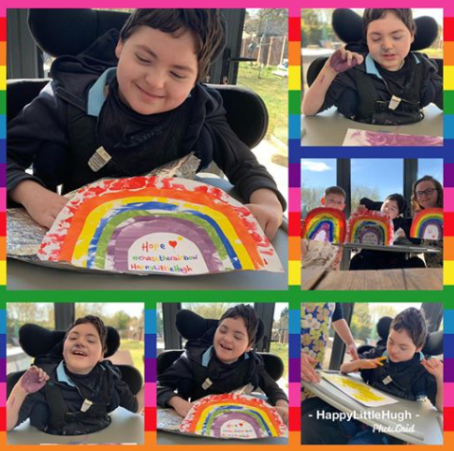
For those of you who follow ‘HappyLittleHuge on Facebook here he is making his rainbow with his mum and brother at home!

Theme & week beginning | Craft  Create a picture to stick in your window!  See pictures below for inspiration! | Sensory Play | Cooking
 |  | Please note all of these activities are only suggestions, please do not put yourself at risk by going to the shops to buy things to support these activities. Be imaginative and creative with what you have at home! The internet is a wonderful thing – I actually don’t know what we did before google!!
23/03/20  Rainbow | Create a rainbow, paint or collage it | Freeze coloured ice cubes and play with them as the melt –
30/03/20  Sunshine | Create a rainbow, paint or collage it | Explore lemons whole/ sliced and added to water | Make/play/ eat banana Yellow Sunny Angel delight.
06/04/20  Easter | Create an Easter Egg Picture | Easter egg water play | Chocolate Easter nest
13/04/20  Animals | Create an animal picture | I’m thinking rabbits – and they love carrots! How many forms of carrot can you play with, (whole, pealed, mashed???) | Carrot soup / Carrot cake
20/04/20  Flowers | Create a flower | 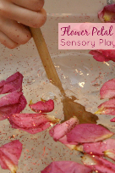  Create a flower magic potion! | Create a flower and then play and explore!
27/04/20  Smiley faces | Create a smiley face | Face paint/ makeup or just enjoy exploring your beautiful faces in the mirror! | Create a happy face Pizza!

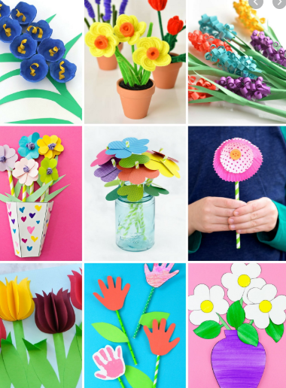
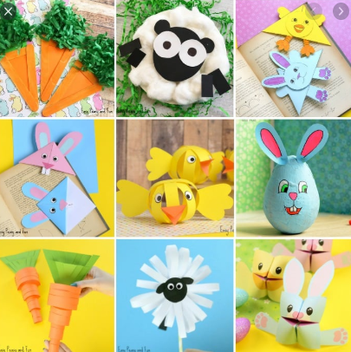
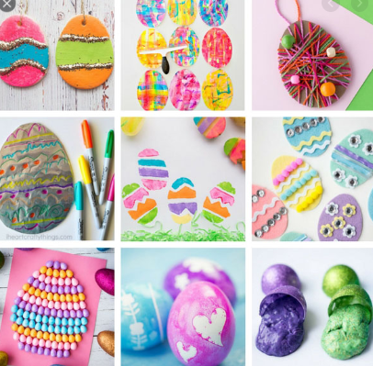
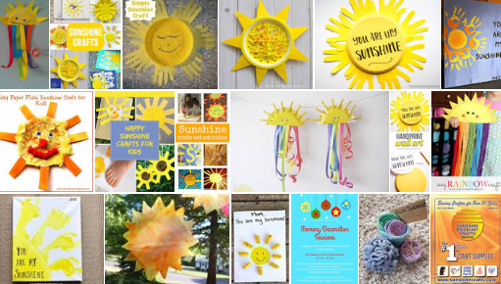

Apps to support home Learning

Help Kids Learn – is a resource we use often at school here in a link to a 14 day free trail – there are apps for the ipad!
https://www.helpkidzlearn.com/updates/school-closure.html

Priory woods – offer a range of free computer resources you may be able to access from home
http://www.priorywoods.middlesbrough.sch.uk/page/?title=Switch+%2F+Touch+Screen+Videos&pid=231

Equals – Free ICT resources https://equals.co.uk/whiteboard-room-pmld/

SENIT – Free ICT resources https://www.senictsoftware.com/

YouTube (search for guided meditation, Makaton Carpark Karaoke)

YouTube – To develop visual skills search for baby sensory visualisations – turn the music down if its driving you crazy!

The senory projects – This list is being added too as resources are being made all for PMLD learners http://www.thesensoryprojects.co.uk/covid19-resources

